Chemical Bonds

Select the alternative that correctly answers the following questions.

1. The name of the ionic compound represented by the formula, Ca(HSO₄)₂ is

a) copper dihydrogen sulfate.
b) copper hydrogen sulfate.
c) calcium hydrogen sulfate.
d) calcium bicarbonate.
e) calcium hydrogen sulfite.

2. Which of the ionic formulas below is written incorrectly?

a) Na₂O
b) Ca(OH)₂
c) Fe₂(SO₄)₃
d) AlOH₃
e) ZnCl₂

3. The correct name of the molecular substance represented by the formula, N₂O is

a) nitrogen dioxide.
b) nitrogen oxide.
c) nitrogen monoxide.
d) dinitrogen monoxide.

The next 3 questions refer to the table below which show some elements in the main groups of the Periodic Table. (Note, Transition metals have been deleted in this table.) Some of the elements have been given numbers rather than symbols.

I | II | III | IV | V | VI | VII | VIII
Li |  | B |  |  | O | F | Ne
1 | 3 |  |  |  | 5 | 6
2 | 4

4. Which elements would you expect to form ionic bonds?

a) 1 and 3. b) 4 and 6
c) 5 and 6 d) Li and 3

5. Elements which contain metallic bonds only are

a) 1, 5 and 6
b) 5 and 6
c) Ne, 5 and 6
d) 1, 2, 3 and 4

6. Which elements are made up of molecules in which covalent bonds are present?

a) 1 and 2 b) 3 and 4
c) 5 and 6 d) 5, 6 and Ne

7. A molecule is

a) a charged atom.
b) made up of two or more atoms held together by covalent bonds.
c) made up of two or more oppositely charged ions held together by electrostatic attraction.
- made up of two metallic atoms held together by the electrostatic attraction of the electrons and metallic ions .

The next four questions are based on the following table, which summarizes the properties of four different substances numbered 1, 11, 111 and 1V.

Substance | Melting Point (ºC) | Electrical Conductivity in Solids | Electrical Conductivity in Molten State | Hardness and Malleability
I | -7 | Non-Conductor | Non-  Conductor | Soft
II | 1083 | Good Conductor | Good Conductor | Hard and Malleable
III | 801 | Non-Conductor | Conducts electricity | Hard and brittle
IV | 3550 | Non-Conductor | Non-Conductor | Hard and brittle

8. Which substance would be a metal?

a) I b) II
c) III d) IV

9. Which substance would be an ionic compound?

a) I b) II
c) III d) IV

10. Which substance would be classified as covalent molecular?

a) I b) II
c) III d) IV

11. Which substance would be classified as a covalent network solid?

a) 1 b) 11
c) 111 d) 1V

12. ‘Ionisation energy’ refers to

a) the amount of energy required to form a positive or negative ion.
b) the amount of energy required to add an electron to an atom in the gaseous phase.
c) the amount of energy required to remove the most loosely bound electron from an aom in the gaseous phase.
d) the amount of energy released when a positive or negative ion is formed.

13. Which elements have the highest ionisation energies?

a) The noble gases.
b) The alkali metals.
c) The transition metals.
d) The halogens.

The next two questions refer to the graph below showing the ionisation energies of the first 20 elements.

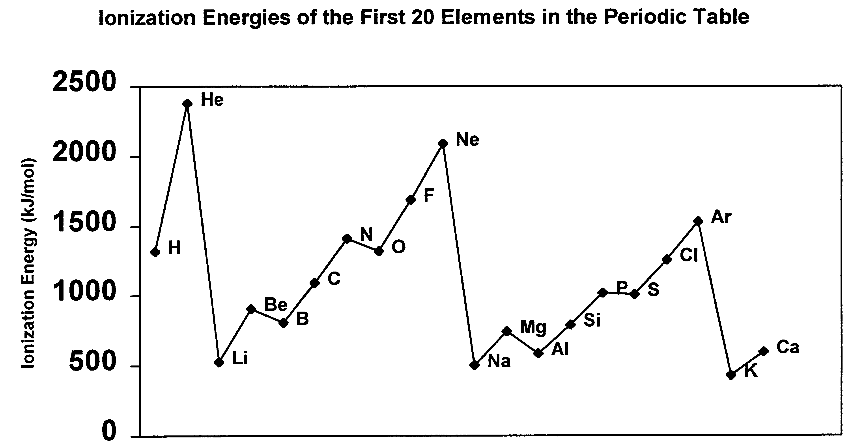

14. Which one of the following best accounts for the general increase in ionisation energy across a row of the periodic table?

a) The decreasing distance between the nucleus and the outer electrons in the atoms of the elements across a row.
b) The increasing nuclear charge within the atoms of the elements across a row.
c) The increasing number of electrons in the atoms of the elements across a row.
d) The increasing number of neutrons in the atoms of the elements across a row.
15. Which one of the following statements is FALSE?

a) Elements that have few valence electrons tend to have low ionisation energies.
b) Inert gases all have high ionisation energies.
c) Generally, as the number of valence electrons increases across a row in the periodic table, so too does ionisation energy.
d) It requires more energy to remove an electron from a p orbital than from an s orbital, as illustrated by the ionisation energies of magnesium and aluminium.

16. The successive ionisation energies for an element are shown in the table below.

IONISATION | IONISATION ENERGY  (kJ moL⁻¹)
1st | 744
2nd | 1457
3rd | 7739
4th | 10547
5th | 13636

Which one of the following statements is true?

a) The element has one valence electron.
b) The element would tend to form positive ions of charge +2.
c) The element would tend to form negative ions of charge –2.
d) The element is a non-metal.

The next three questions are based on the information in the table below which shows successive ionisation energies of five unidentified elements.

Successive Ionization energy (kJ mol ^{–1})
ELEMENT | 1ST | 2ND | 3RD | 4TH | 5TH
A | 906 | 1763 | 14855 | 21013
B | 425 | 3058 | 4418 | 5883 | 7982
C | 744 | 1457 | 7739 | 10547 | 13636
D | 1257 | 2303 | 3828 | 5164 | 6548
E | 793 | 1583 | 3238 | 4362 | 16098

17. How many valence electrons does element B have?

- 1
- 2
- 3
- 4
18. To which group of the periodic table would element E most likely belong?

a) Group I.
b) Group II.
c) Group IV.
d) Group V.
e) Group VII.

19. Which two elements are most likely to belong to the same group of the periodic table?

a) A and B.
b) B and E.
c) A and C.
d) D and E.
e) A and E.

20. Which one of the following represents the formula of perchlorate ion?

a) ClO₄⁻
b) ClO₃⁻
c) ClO₂⁻
d) ClO⁻

21. The formula of the dihydrogen phosphate ion is

a) SO₄²⁻
b) HSO₄⁻
c) HPO₄²⁻
d) H₂PO₄²⁻

22. Which one of the following ions is colorless in aqueous solution?

a) Co²⁺
b) Cr³⁺
c) Mg²⁺
d) Fe²⁺

23. Which one of the following polyatomic ions is orange in aqueous solution?

a) CrO₄²⁻
b) MnO₄⁻
c) Cr₂O₇²⁻
d) [Cu(NH₃)₄]²⁺

24. The type of bonding between the atoms within the following polyatomic ion, OH⁻ is

a) covalent bonding.
b) ionic bonding.
c) metallic bonding.
d) hydrogen bonding.

25. The correct formula for mercury (I) hydroxide is

a) HgOH
b) Hg(OH)₂
c) Hg₂(OH)
d) Hg₂(OH)₂

26. The name of the ionic compound, SnCl₄ is

a) tin tetrachloride.
b) Tin (I) chloride.
c) Tin (II) chloride.
d) Tin (IV) chloride.

27. The electron dot diagram of MgCl₂ can be best represented by
..
a) Mg : Cl : Mg
..
..
b) Mg²⁺ 2 [ : Cl : ]⁻
..
..
c) Mg²⁺ 2 [ : Cl . ]⁻
..
..
d) Mg²⁺ [ : Cl : ]⁻
..
28. The electron dot diagram for the polyatomic ion, CO₃²⁻ is best represented by

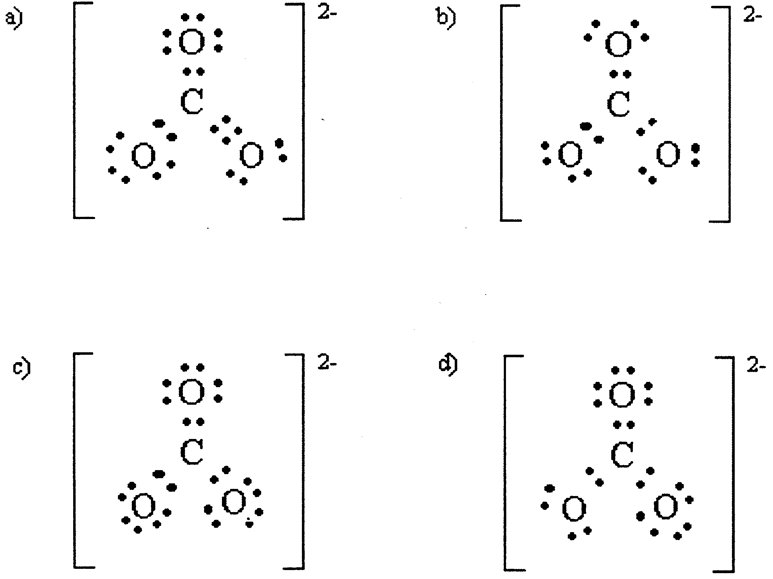

29. Which one of the following elements is the most electronegative?

a) Ca
b) Fe
c) S
d) Cl

30. An ionic bond is most likely to form between two elements

a) whose atoms have high electronegativities.
b) whose atoms have low electronegativities.
c) whose atoms have very different electronegativities.
d) whose atoms have high ionisation energies.
e) whose atoms have low ionisation energies.

31. Study the table below which provides information for the compound BF₃. Which alternative correctly describes this compound?

 | Type of Bonding | Presence or  Absence of Polar Bonds | Molecular Polarity | Shape of Molecules
a) | Covalent | Present | Non-polar | Pyramidal
b) | Covalent | Present | Non-polar | Triangular planar
c) | Covalent | Absent | Non-polar | Tetrahedral
d) | Ionic | Present | Polar | Triangular planar

32. Consider the molecular shape and polarity or non-polarity of ammonia molecules. Which one of the following statements is true?

a) Each molecule of ammonia is non-polar and has a planar triangular shape.
b) Each molecule of ammonia is polar and has a planar triangular shape.
c) Each molecule of ammonia is non-polar and has a pyramidal shape.
d) Each molecule of ammonia is polar and has a pyramidal shape.

33. Which one of the following molecules is polar?

a) CH₄
b) CCl₄
c) BF₃
d) HCl

34. Which one of the following is NOT a van der Waals force?

a) A covalent bond.
b) Dipole-dipole forces.
c) Dispersion forces.
d) Hydrogen bonds.

35. Which one of the following is the weakest type of force that can exist between atoms or molecules?

a) Dispersion force.
b) Dipole-dipole force.
c) Hydrogen bond.
d) Covalent bond.

36. Dispersion forces are the predominant type of force between atoms or molecules of

a) covalent molecular substances whose atoms or molecules are polar.
b) covalent molecular substances whose atoms or molecules are non-polar.
c) metals.
d) covalent network substances.

37. In which one of the following molecules would hydrogen bonding play a role in intermolecular attractive forces?

a) CH₄
b) HI
c) NH₃
d) C₃H₈

38. In order of increasing boiling points (i.e lowest to highest boiling point), you would arrange the substances: H₂O, CH₄, C₂H₆, CH₃CH₂OH and CH₃COCH₃ as follows:

a) H₂O, CH₃CH₂OH, CH₃COCH_{3,} C₂H_{6,} CH_{4.}
b) CH_{4,} C₂H_{6,} CH₃COCH₃, CH₃CH₂OH, H₂O.
c) CH₃COCH_{3,} CH₃CH₂OH, CH_{4,} C₂H_{6,,}, H₂O.
d) CH_{4,} CH₃CH₂OH, CH₃COCH₃, CH₃CH₂OH, C₂H_{6,} H₂O.

39. Which one of the elements below is the most electronegative?

a) F
b) Cl
c) Br
d) I

40. Which one of the following molecules is NOT linear?

a) CO₂
b) SO₂
c) HCl
d) BeF₂

41. Which one of the following substances would be least soluble in water?

a) NH₃
b) HF
c) CH₃COOH
d) C₄H₁₀
42. Which one of the following substances would have molecules that are polar?

a) Cl₂
b) CH₄
c) PCl₃
d) BF₃

43. Which one of the following molecules has a v-shape (bent)?

a) SO₂
b) BeF₂
c) CO₂
d) NH₃

44. Which one of the following substances would you expect to be least soluble in water?

a) ethane, C₂H₆.
b) Ethanol, C₂H₅OH
c) Ethanal,, CH₃CHO
d) Diethyl ether, CH₃CH₂OCH₂CH₃

45. A substance has the following characteristics:

1. Crystalline.
2. Has a boiling point of 1100ºC.
3. Is hard and brittle.
4. Does not conduct electricity at room temperature.
5. Conducts electricity in liquid form.
6. Is a strong electrolyte.

Based on this information, the substance would best be classified as

a) metallic.
b) ionic.
c) covalent molecular.
d) covalent network.

46. Graphite is unusual in that it can conduct electricity, yet is classified as a covalent network solid. Which one of the following statements best explains this?

a) Each carbon atom in graphite forms double covalent bonds with two neighboring carbon atoms, leaving two electrons per atom delocalised and free to move throughout the structure.
b) Each carbon atom in graphite forms double covalent bonds with two neighboring carbon atoms, leaving two electrons per atom delocalised and free to move between layers of covalently bonded carbon atoms.
c) Each carbon atom in graphite shares three electrons with three neighboring carbon atoms. The fourth electron from each carbon atom is delocalised and free to move within the layers of covalently bonded carbon atoms.
d) Each carbon atom in graphite shares three electrons with three neighboring carbon atoms. The fourth electron from each carbon atom is delocalised and free to move between layers of covalently bonded carbon atoms.

47. Which of the following solids would be the best electrical conductor?

a) Sulfur.
b) Sodium chloride.
c) Graphite.
d) Iodine.

48. Which of the following does NOT exist as discrete molecules in the solid state?

a) Carbon dioxide.
b) Nitrogen monoxide.
c) Water
d) Silicon dioxide.
e) Ammonia.

49. How many lone (non bonding) pairs of electrons would be found in a molecule of H₂O?

- 1
- 2
- 3
- none.

50. Which of the following pairs of elements are most likely to form covalent bonds?

I. Hydrogen and oxygen.
II. Nitrogen and nitrogen.
III. Calcium and chlorine.
IV. Zinc and oxygen.
V. Carbon and hydrogen.

The pairs which can form covalent bonds are

a) I, II and V.
b) I and II.
c) I, II and IV.
d) III and V.

51. Which of the following would be least soluble in ethanol?

a) Water, H₂O.
b) Ammonia, NH₃.
c) Butanol, CH₃-CH₂-CH₂-CH-OH.
d) Butane, CH₃-CH₂-CH₂-CH₃.

52. Which one of the following compounds is incorrectly named?

a) NaClO – Sodium hypochlorite.
b) MgS – Magnesium sulfide.
c) NaI – Sodium iodide.
d) K₂CrO₄ – Potassium dichromate.

53. Which one of the following is the correctly written formula of the molecular compound, dinitrogen tetroxide?

a) NO₄.
b) N₂O₄.
c) N₂O₅.
d) N₅O₂.
e) N₅O₂.

54. Which of the following correctly represents an ammonia molecule?
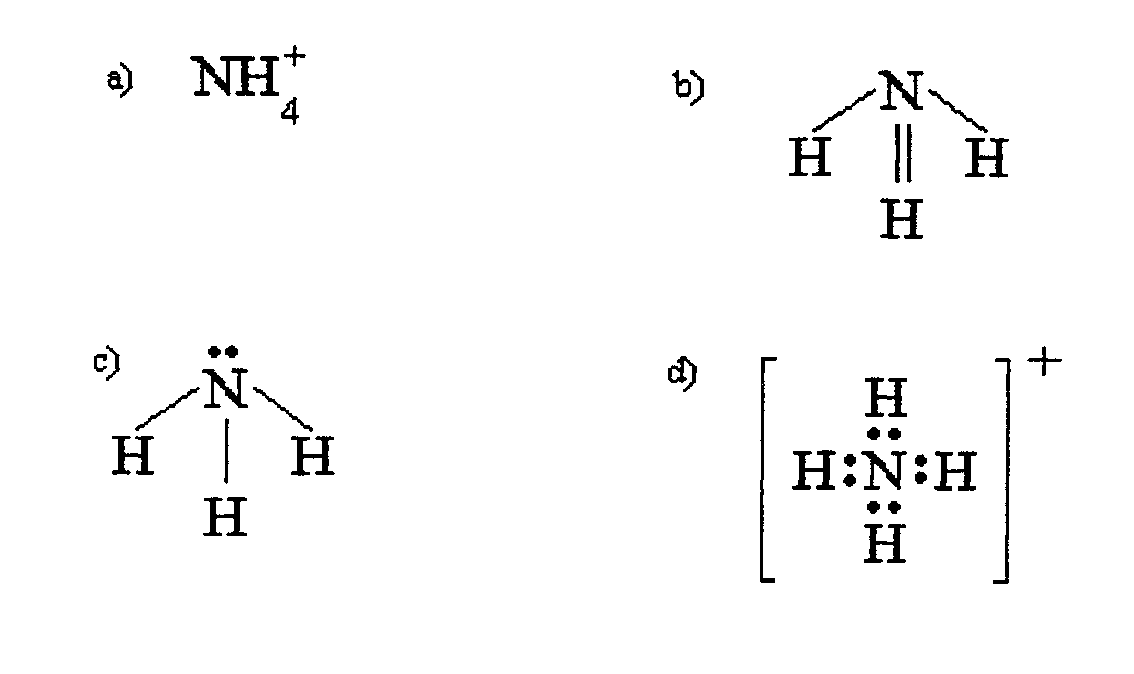

55. Which of the following is NOT true of graphite.

a) It is an allotrope of carbon.
b) It is soft and slippery.
c) It can be split into sheets due to weak bonding between its layers.
d) It is a non-conductor of electricity.

56. The following list describes four characteristics of a metal:

1. Soft and light colored.
2. Reacts vigorously with water, liberating hydrogen gas.
3. Reacts explosively with dilute acids.
4. Forms colorless ions.

Which one of the following metals has all these features?

a) Magnesium.
b) Calcium.
c) Sodium.
d) Aluminium.

57. Which one of the metals below has all the following characteristics?

1. Light, silver colored metal.
2. Does not react readily with water at room temperature.
3. Burns in air with an intense, white light.
4. Burns in carbon dioxide to form a metal oxide and carbon

a) Magnesium.
b) Calcium.
c) Sodium.
d) Aluminium.

58. Which one of the following statements about aluminium metal is FALSE?

a) Aluminium does not react readily with pure water but is rapidly corroded by salt water.
b) Aluminium reacts readily with hydrochloric acid, liberating hydrogen.
c) Aluminium forms the insoluble base Al(OH)₃, which can only be dissolved by the addition of an acid.
- Aluminium ions, Al³⁺, are colorless and non-toxic.

